

Fish Preferences

Marketing Analytics (MIS 382N)



September 13, 2016

Davis Townsend

Professor Sonnier

**Model Parameters**

|  |  |  |  |  |  |
| --- | --- | --- | --- | --- | --- |
| **Intercept** | **Tuna** | **Halibut** | **Wild** | **Farm** | **Price** |
| -0.500114207 | -0.31253728 | -0.463082845 | 2.234767541 | 0.94992536 | -0.948187626 |

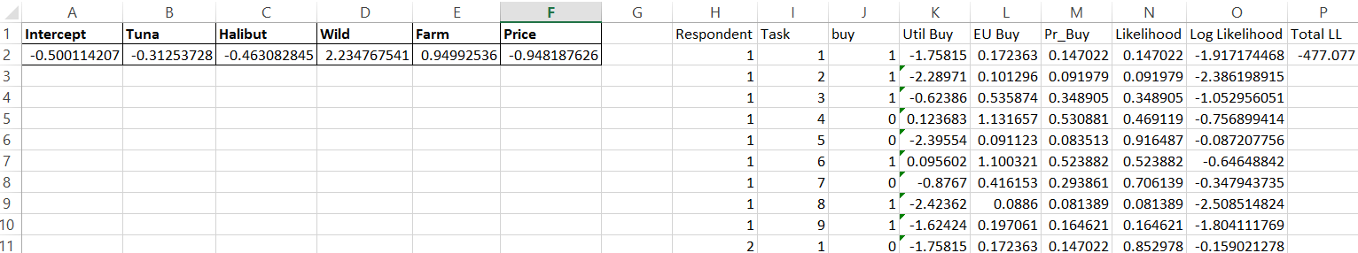

I created the model similar to the in class model by creating the parameters and initially setting them to be 0, then calculating the utility of buying by taking the sum product of the parameters and the variables given to us for each respondent and task. I then calculated the expected utility of buying by exponentiating the buy utilities. Next I calculated the probability of buying by taking the quotient of *EU_Buy / (1+EU_Buy).* For the likelihood I used the equation: *M2^J2*(1-M2)^(1-J2)* where M2 is the probability of Buy and J2 is either 0 or 1 representing if the respondent for each given task would buy or not buy. Then I took the natural log of the likelihood and summed these up for each respondent and task to get the total log likelihood. Finally I used the Excel solved to change the Beta Coefficients to find the maximum value of Total Log Likelihood (essentially finding our maximum likelihood estimate) and found the Beta Coefficients as shown.

2) For the predicted probabilities of buying for respondents 1, 50, and 100 and tasks 1-9 I simply took the likelihoods for the respective respondent and task. The likelihood represents the probabilities of whether a respondent will buy or not given that they said they will buy or not for the given profile (task)

|  |  |  |  |
| --- | --- | --- | --- |
|  | Predicted Probabilities of Buying | | |
|  | Respondent 1 | Respondent 50 | Respondent 100 |
| Task 1 | 0.147021791 | 0.147021791 | 0.852978209 |
| Task 2 | 0.091978639 | 0.908021361 | 0.908021361 |
| Task 3 | 0.348904843 | 0.651095157 | 0.651095157 |
| Task 4 | 0.469118717 | 0.530881283 | 0.469118717 |
| Task 5 | 0.916486671 | 0.916486671 | 0.916486671 |
| Task 6 | 0.523882205 | 0.523882205 | 0.523882205 |
| Task 7 | 0.706138606 | 0.293861394 | 0.293861394 |
| Task 8 | 0.081389027 | 0.918610973 | 0.918610973 |
| Task 9 | 0.164620613 | 0.835379387 | 0.835379387 |

3)

|  |  |  |  |  |  |  |
| --- | --- | --- | --- | --- | --- | --- |
|  |  |  |  |  |  | **Derived Importance** |
| **Type** |  |  | **MAX** | **MIN** | **DIFF** | **14.18%** |
| Halibut | -0.463082845 |  | 0 | -0.46308 | 0.463083 |  |
| Salmon | 0 |  |  |  |  |  |
| Tuna | -0.31253728 |  |  |  |  |  |
| **Method** |  |  |  |  |  | **68.41%** |
| Wild | 2.234767541 |  | 2.234767541 | 0 | 2.234768 |  |
| Farm | 0.94992536 |  |  |  |  |  |
| gmo | 0 |  |  |  |  |  |
| **Price (in $10's)** | |  |  |  |  | **17.42%** |
| 1.399 | -1.326514488 |  | -1.326514488 | -1.89543 | 0.568913 |  |
| 1.699 | -1.610970776 |  |  |  |  |  |
| 1.999 | -1.895427064 |  |  |  |  |  |
|  |  |  |  |  |  |  |
|  |  |  |  |  | **Total** |  |
|  |  |  |  |  | 3.266763 |  |

To find the derived importance I did the following: Get Beta coefficients for each category, find the max and min for each attribute, find the absolute difference, and then calculate percent importance by taking the difference of each attribute divided by the sum of the differences, called Total.

4) 

This first chart shows the product share with the original attributes given. The utilities are found by taking the sum product of the Beta coefficients at the top and the actual 0 or 1 values for the attributes. These utilities are exponentiated to find *Exp(U)* and then for each product we take its *Exp(U)* and divide it by the sum of all the *Exp(U)* to get the percent share.

|  |  |  |  |  |  |  |
| --- | --- | --- | --- | --- | --- | --- |
| **Product Shares as a function of Product Price** | | | | |  |  |
|  |  |  |  |  | **% Change** | **Elasticity** |
| **Price of  Product 1** | **$13.99** | **$15.99** | **$17.99** | **$19.99** | 35.31% |  |
| Product 1 | 29.26% | 25.49% | 22.06% | 18.97% | -42.65% | -1.207741489 |
| Product 2 | 33.08% | 34.85% | 36.45% | 37.90% | 13.55% | 0.383814969 |
| Product 3 | 11.07% | 11.65% | 12.19% | 12.67% | 13.55% | 0.383814969 |
| None | 26.59% | 28.01% | 29.30% | 30.46% | 13.55% | 0.383814969 |

This chart is just showing how the product share changes as the price changes for product 1. I did this by doing the exact same type of table above but made 4 of them, each with one of the prices. I aggregated the results into this table above. I then calculated the percent change in market share by taking the difference of the highest and lowest product share and dividing it by the average of these 2 values. Lastly I calculated the Elasticity by taken the percent change in price (35.31%) by the percent change in product share for each product, given the price changes. Notice that the % changes and elasticities for the products whose price is not changing is constant.

This is simply a graph to represent the same data graphically that I showed in the table above.

5) Parts a, b, c

